* When we create and run a job, a “workspace” directory will be created in Jenkins home directory and every job will have separate sub folders inside that
* And that is the area for job execution
* In Jenkins, we need to do Jenkins application level configuration and job level configuration as well
* Configure system, global tool configuration, manage plugins. These are the 3 we mainly used to configure Jenkins under manage Jenkins settings

**Configure System Settings**

**Home directory:**

* Under manage Jenkins 🡪configuration settings, we can find the Jenkins **home directory** on the top
* /var/lib/Jenkins is the default home directory for jenkins



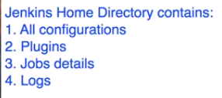

* We can change it if we want as per the below instructions

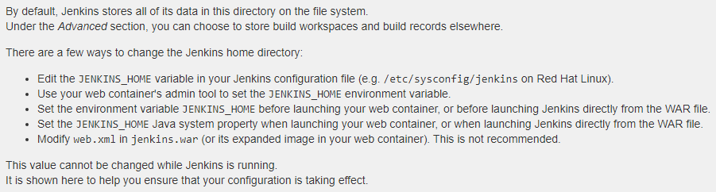

* We can set the JENKINS_HOME location when we run war file
* Also, we can do as below when we run Jenkins in tomcat

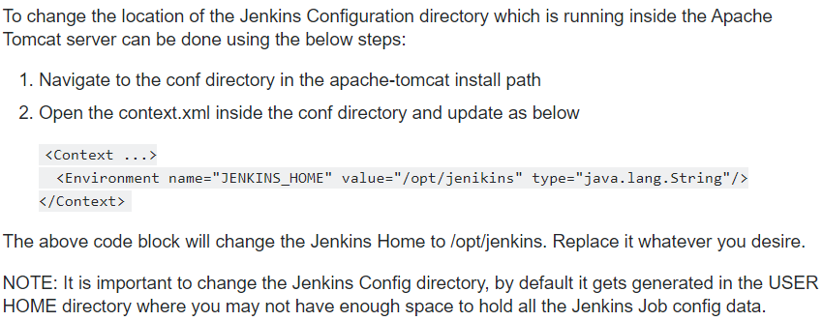

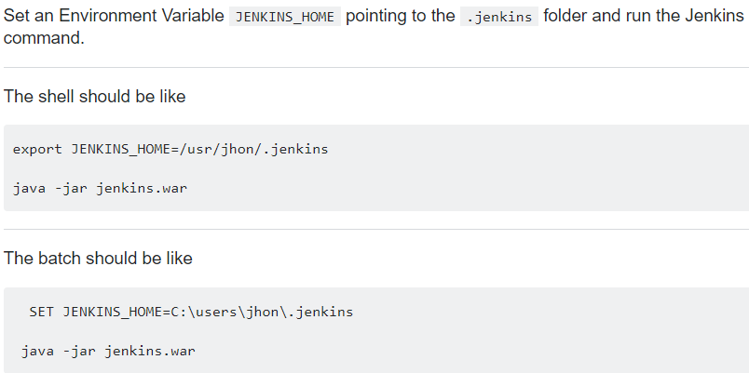

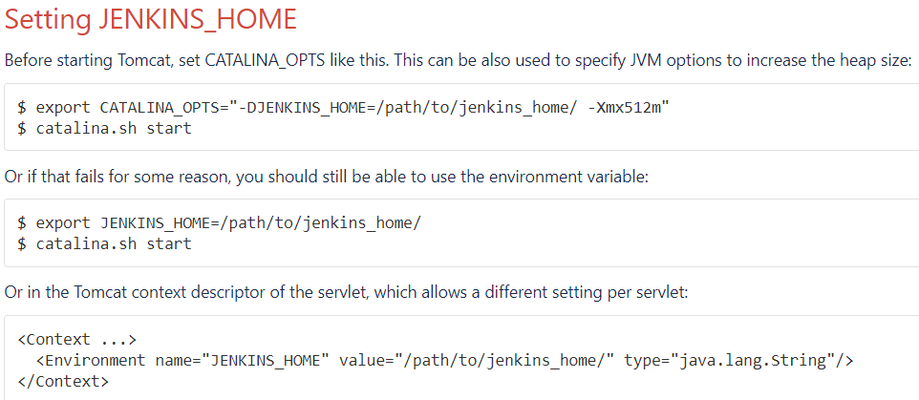

**System message:**

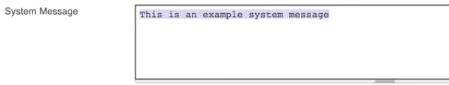

* If we put any **system message** here, it will be displayed in Jenkins home directory as below

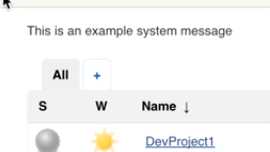

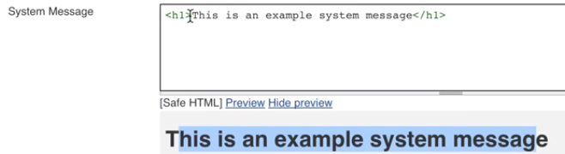

* We can also use the html tags for headings and click on preview to see that



* We need to change the **marker formatter** if we are unable to use html. This can be done in global security settings

**Labels:**

* **Labels** are used to set a label name on slaves as below
* We can use the labels to execute a job when its matching certain label

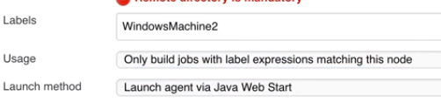

* Then we can use the label at the restrict where this project can be run

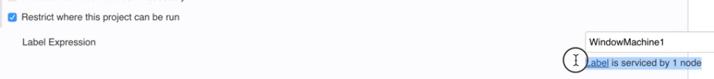

**Quiet period:**



* **Quite period** us used for the time interval before job gets triggered. This will be useful as sometimes commit may take time to load the files.

**Restrict project naming:**

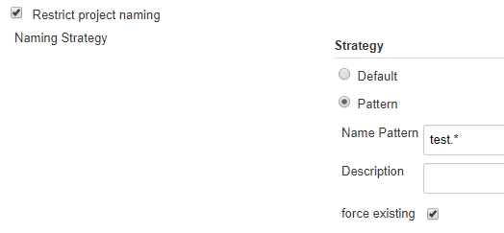

* **Restrict project** naming is used to restrict the project name. as above, we can only create a job name starts with test. It won’t allow any other names

**Global properties:**

* This can be used to set any variable and its value globally, and we can use those variables in jobs

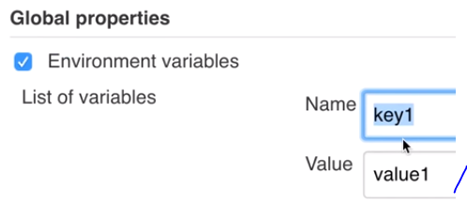

* **Global properties** used to set as above, give name and value and this can be used in jobs as below

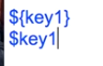

**Executor:**

* A slot for execution of work defined by a [Pipeline](https://jenkins.io/doc/book/glossary/#pipeline) or [Project](https://jenkins.io/doc/book/glossary/#project) on a [Node](https://jenkins.io/doc/book/glossary/#node). A Node may have zero or more Executors configured which corresponds to how many concurrent Projects or Pipelines are able to execute on that Node
* A Jenkins executor is one of the basic building blocks which allow a build to run on a node/slave (e.g. build server). Think of an executor as a single “process ID”, or as the basic unit of resource that Jenkins executes on your machine to run a build.
* In Jenkins we can have multiple threads, one thread doing one task and another doing another task. This we can do it with executors
* A slot for execution of work defined by a [Pipeline](https://jenkins.io/doc/book/glossary/#pipeline) or [Project](https://jenkins.io/doc/book/glossary/#project) on a [Node](https://jenkins.io/doc/book/glossary/#node). A Node may have zero or more Executors configured which corresponds to how many concurrent Projects or Pipelines are able to execute on that Node.

**Jenkins URL:**

* We can change **Jenkins URL**, system admin email id as below
* Jenkins can't determine its URL on its own. So, when it needs to create full links that's where the URL is taken from. In general, even if you specify the wrong URL it should not affect the way Jenkins works in any significant way. It certainly has no effect on the URL that you enter in your browser to connect to Jenkins server. You can either specify http://localhost:8080(when connecting from your machine and if you started Jenkins on port 8080) or http://<machine_hostname>:8080 when connecting from anywhere.
* So, no matter what you specify it has no effect on connecting to Jenkins
* This is only to generate the links in emails Jenkins sends

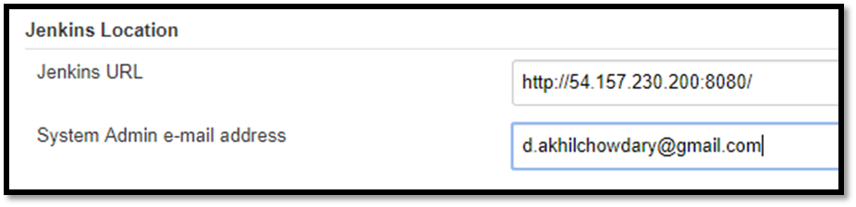

**Workspace sharing:**

* Shared workspace can be used when multiple jobs using the same repository code. This can save disk space

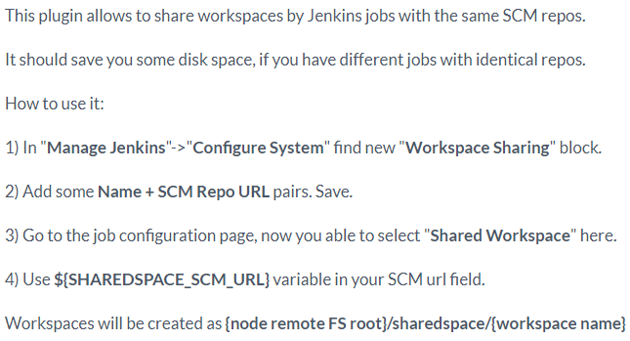

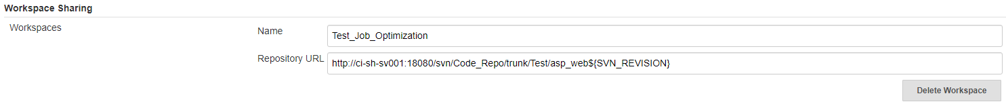

**Extended email notification:**

* We can give **extended email notification**

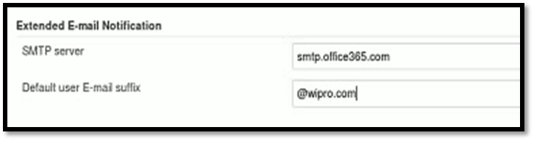

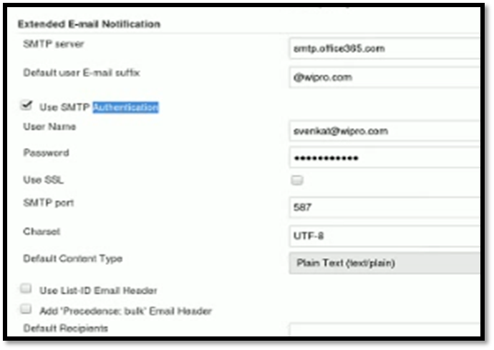

* We need to give the authentication also. For Gmail also by clicking advance settings

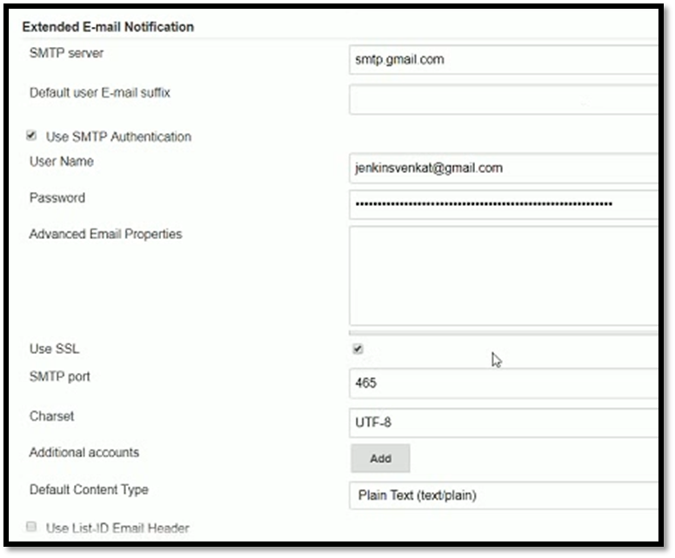

* Remaining are better to leave as default, those are internal Jenkins environment variables

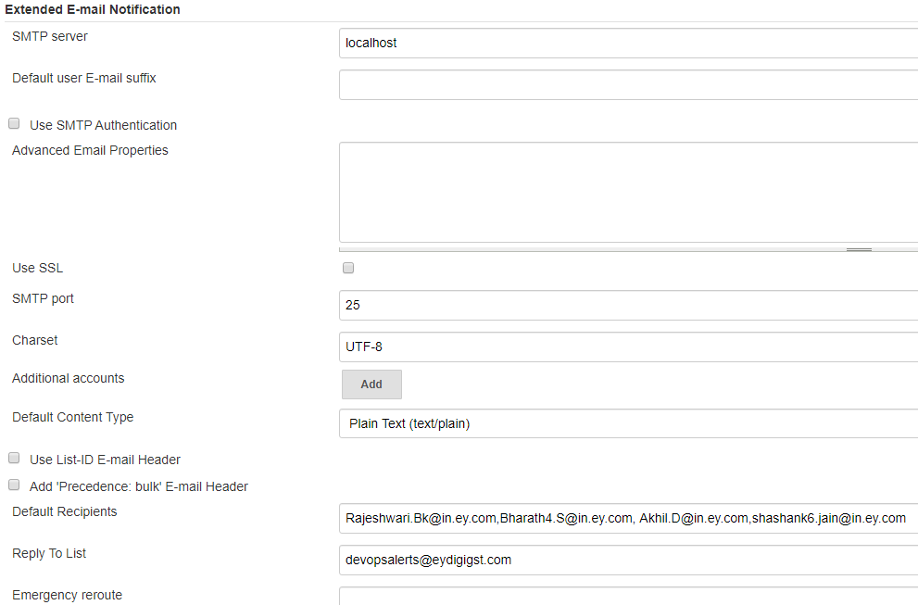

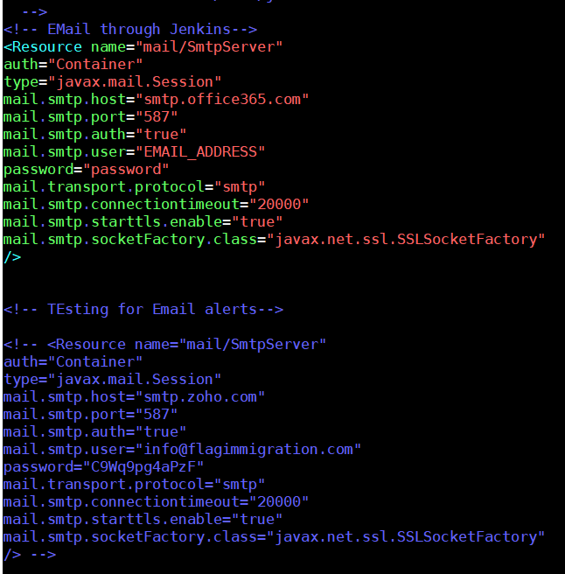

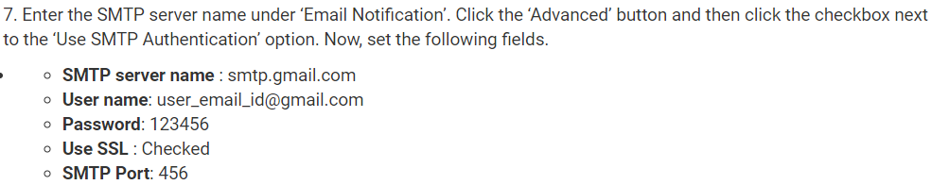

**Email notification:**

* We can set **email notification** for job alerts as below at the application level

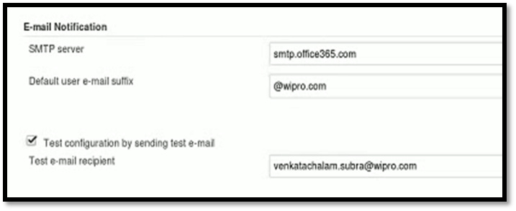

* Configuration for Gmail

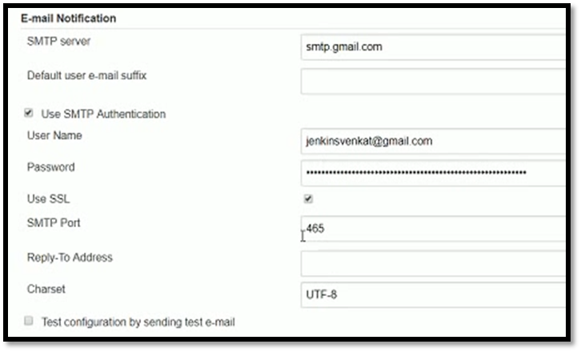

* SMTP port is always 465
* Default user email suffix is optional
* In google account settings, we need to allow less secure apps, then only Jenkins can send email from Gmail
* Here with these two things, we can set what the email server configured and in job we need to tell whom we need to send an email
* We can test the configuration. We receive the mail from admin mail
* Setting up these things in application level is enough

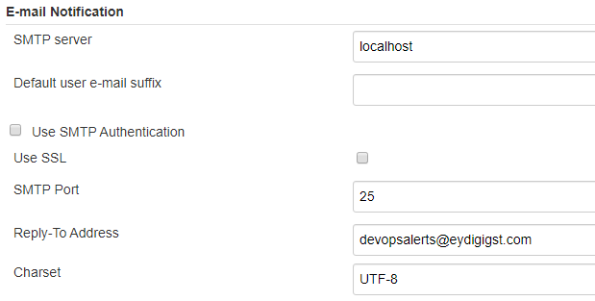

**Email vs extended email notification:**

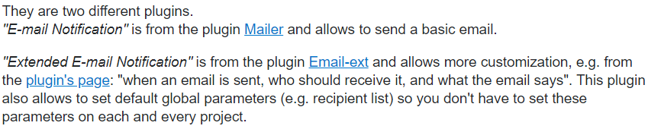

* We have to configure the mail configuration for both in configure system settings so that we can use them while creating the jobs